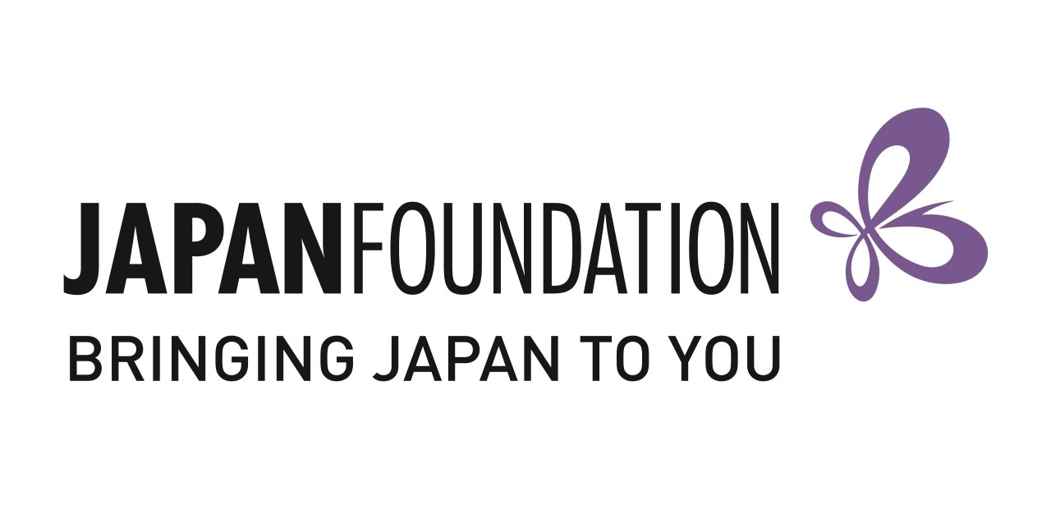

APPLICATION FOR BORROWING CULTURAL GOODS

School Name: ………………………………………………..………………………….
Position/Title: ……………………………………………………………………………
Name: …..…………………………...……………………………………….………….
Address: ………………………………………………………………………………....
Telephone: …………………………........................................................................
Email address: ……………………………………………………………………..…...
Date required: ……………..………...….. Return date: …..………….…..………..
Purpose of use: ……..………………………………………………..…………....

Please circle which kit you would like to borrow:
A. Basic Information B. School Life
C. Traditional Japan D. Japanese Cuisine

BORROWING REGULATIONS
1. Cultural items are to be used for education purposes by school and institutions only. They must not be used for personal or commercial gain.
2. Items are for display only with the exception of Yukata, Happi, wigs and school uniforms which must be cleaned before being returned.
3. The Japan Foundation, Sydney will cover one way mailing costs to deliver the borrowed goods to your school/institution. The school/institution is responsible for expenses associated with returning the goods.
4. If the borrower loses or irreparably damages any items, the full replacement value must be paid by the borrower to The Japan Foundation, Sydney.

I have read the above regulations and agree to abide by the conditions and accept responsibility for all items borrowed.

Signature: ……………………………………………. Date: …………………

Please email your application form to loan@jpf.org.au.

Please note: Applications will only be accepted up to 2 months prior to your required date.

